Challenge: Material & Texture

As a challenge, try to replicate the three materials shown below. The first one is a simple albedo with

a high roughness. The second one uses transparency, and the third one uses a texture value.

Example:

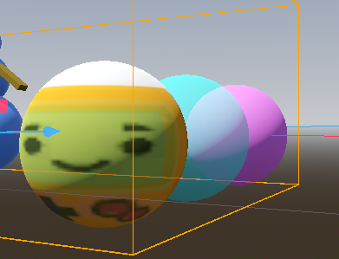

Your Attempt:

|  |
| --- |